Research of Babies Sleep Cycles.

Sleep movement and Noise

Over a 24-hour period a baby can sleep for 14-15 hours, this is broken up into 2-to-3-hour periods, as you can see from the below graph the sleep cycle of a child changes rapidly as they get older. Just after being born, the child will almost sleep equally through the night and day. As they get older their sleep cycle will closer resemble a normal pattern, that being, the child sleeps mostly during the night.

Newborn babies are very active sleepers. They move and wake up a lot, this is down to the fact that that they spend half their sleep in REM (Rapid Eye Movement) or active sleep. The baby’s eyes move around (while closed), They move their arms and legs and open and close their mouths. The other half of their sleep is spent in NREM (Non-rapid Eye Movement) or quiet sleep. This is where the baby is fully asleep and does not move and make noise as frequently. As they get older there sleeping becomes sounder and they sleep better through the night.

Parallel to movement, Newborn babies are also quite noisy sleepers, their breathing can be irregular and they may wake up briefly and whimper. It is recommended by doctors to wait out the babies first whimpers. It is very likely that the baby is still in a light sleep. The child should only be picked up and comforted if its clear that they are awake.

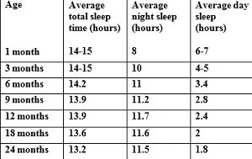

Baby sleep chart based on Swiss study (Iglowstein et al 2003)

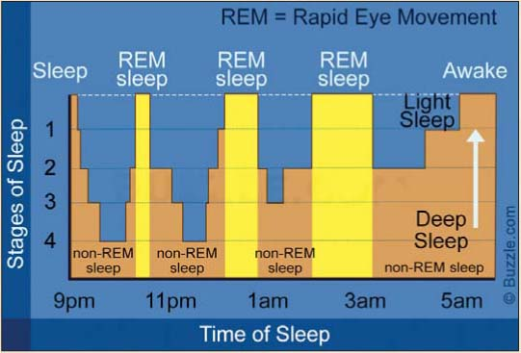

Music/ White noise

As a newborn baby is still getting used to the world, they may not be used to silence. Before they are born, they were constantly hearing noises made by their mother most importantly her heartbeat. Newborn babies may find silence mildly distressing.

Studies have shown that, the hum of a fan/soft music or white noise being emmitted through a speaker may ease this discomfort.

Again, as with movement and noise this eases as they get older, as their sleeping pattern becomes more regular.

Applying research to the scope of our project

My research has highlighted areas which may prove to be problematic.

* There is a big difference in the sleep cycles of newborn babies and babies as they get older, this will have to be considered when designing the prototype, A one size fits all strategy will not work.
* There are also quite varied differences between one baby to the next. A configuration that accurately monitors and comforts one baby may not be suitable for another.
* For example, as outlined in the research I have read, soft music or a lullaby playing may comfort some babies and it may also hinder another child’s sleep. This can also be said for white noise. This may aid or damage a newborns ability to fall asleep, depending on the specific baby.
* Differentiating between a baby that is in a very light REM sleep and a baby that is awake will prove very difficult as while in light sleep, the baby may move around and make noise.

Possible solutions

* The main takeaway from the research was that there is a great need to be able to adjust the device and its responses based on both the babies age and individuality.
* We could do this by having two are three different configurations built into the devices, With the tolerances for the sensor’s tailored to a specific age group.

E.g., Greater tolerances for newborns as not to trigger the responses while the baby is still in a light sleep and tighter tolerances for when the baby gets older as he or she will not be moving around as much nor making as much noise.

* The noise that should be played when the baby wakes up should be able to be changed. The parents may then choose the noise that souths their baby the most. Lullaby’s/ heartbeats and white noise all could be including in the device.
* A further iteration of the device could include a report of the baby’s night sleep, similar to a smart watch, giving information on how long the child slept for, when the baby was in REM or EREM sleep, what noise soothed that child most. This would help inform the parents decision of what configuration would suit their child. Using data analytics, over time the device may also be able to suggest the optimal setting based on the sleeping data over a period.

Sources:

[Amy O’Connor, medically reviewed by Marvin Resmovits (01/05/20), “Newborn and baby sleep basics”, Viewed 13/02/21, <https://www.whattoexpect.com/first-year/newborn-sleep.aspx>]

[Danielle Pacheco (17/12/20), “How your baby’s sleep cycle deferrers from your own”, viewed 13/02/21, <https://www.sleepfoundation.org/baby-sleep/baby-sleep-cycle>]

[Author unknown, (date unknown), “What is white noise and how can it help your baby sleep?” viewed 13/02/21, <https://www.motherandbaby.co.uk/first-year/baby/sleep/white-noise-baby>]

[Emily DeJeu (28/09/19), “Your Baby’s Changing Sleep Patterns: Birth-12 Months”, viewed 16/02/20, https://www.babysleepsite.com/baby-sleep-patterns/baby-sleep-patterns-birth-to-12-months/]